Lab 3: Deployment of Ubuntu OS in Azure Virtual Machine and Installing Apache2 for Static Website Deployment

Theory:
1. Azure Virtual Machine (VM):
A Virtual Machine in Azure is an emulated computer system that runs on the cloud. It allows users to deploy and run operating systems and applications without requiring physical hardware. VMs are widely used for development, testing, and hosting applications or websites.
2. Ubuntu Operating System:
Ubuntu is a popular open-source Linux distribution. It is widely used for server deployment due to its stability, security, and large repository of software packages. Deploying Ubuntu on a VM provides a cost-effective and flexible environment for hosting applications.
3. Apache2 Web Server:
Apache2 is a free, open-source web server software that allows hosting of websites. It supports static and dynamic content, handles HTTP requests, and is highly configurable. Installing Apache2 on Ubuntu allows users to deploy static websites easily.
4. Static Website Deployment:
A static website consists of fixed content (HTML, CSS, JavaScript) served to users as-is. Unlike dynamic websites, static websites do not require server-side processing, making them faster and easier to deploy on servers like Apache2.

Steps:
- Create a free Microsoft Azure Account:

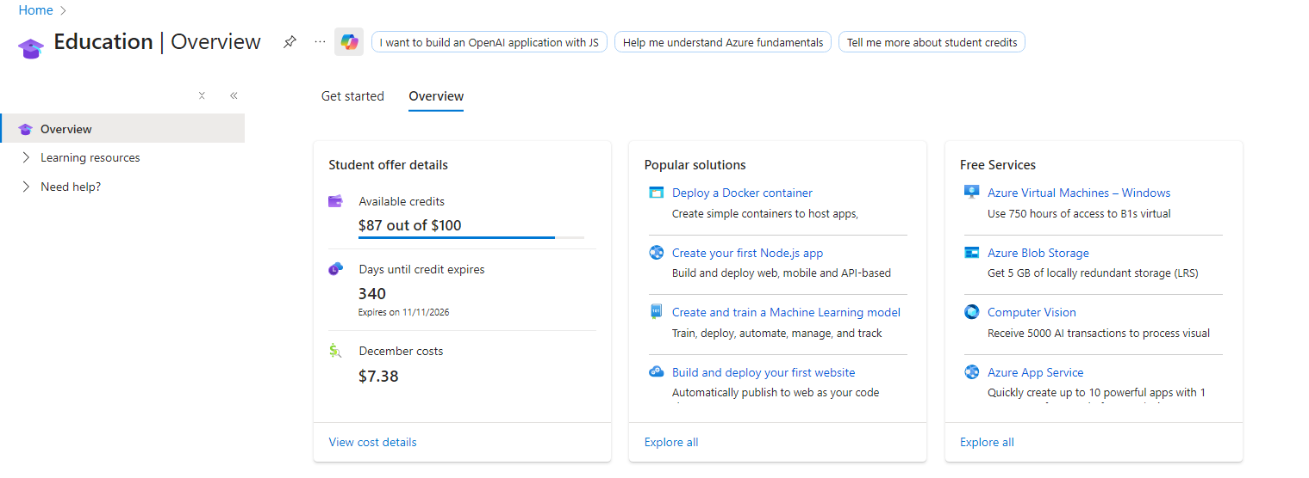

- Go to Home > Virtual Machine and set one up with the required specifications

- Create a Resource Group
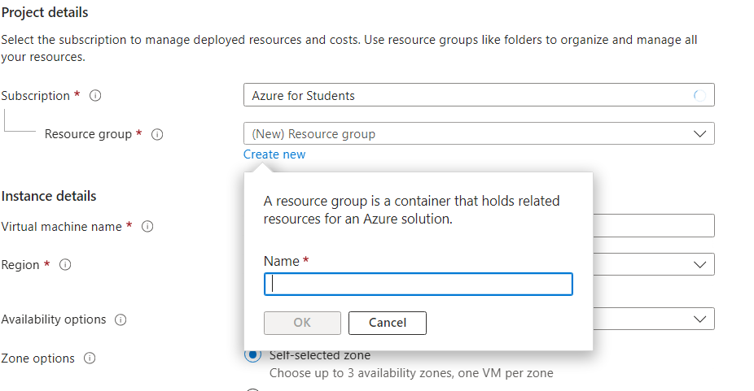

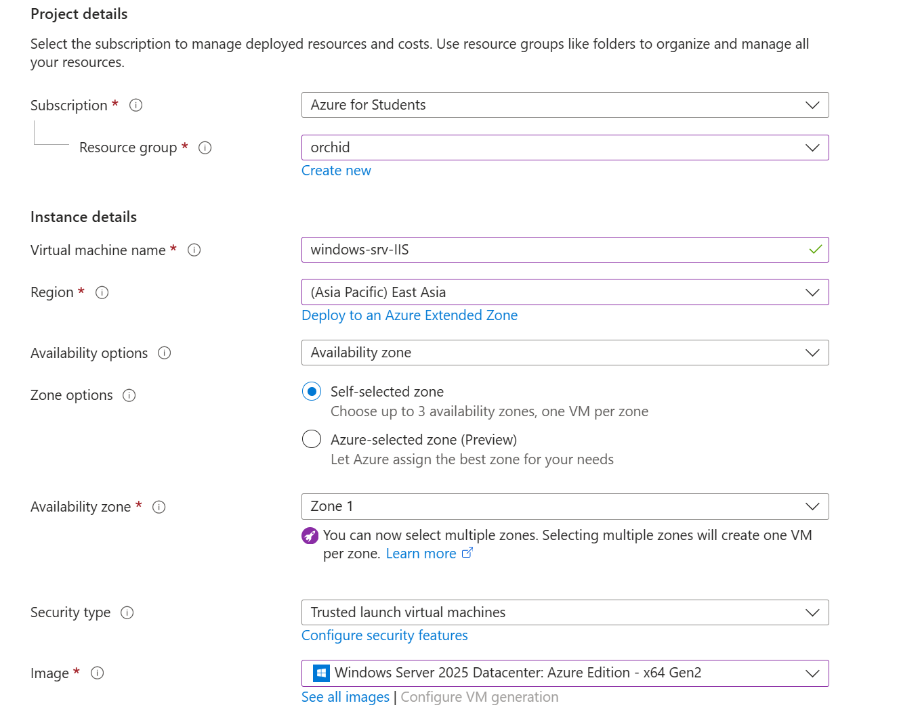

- Choose the size and cost of VM according to your need:
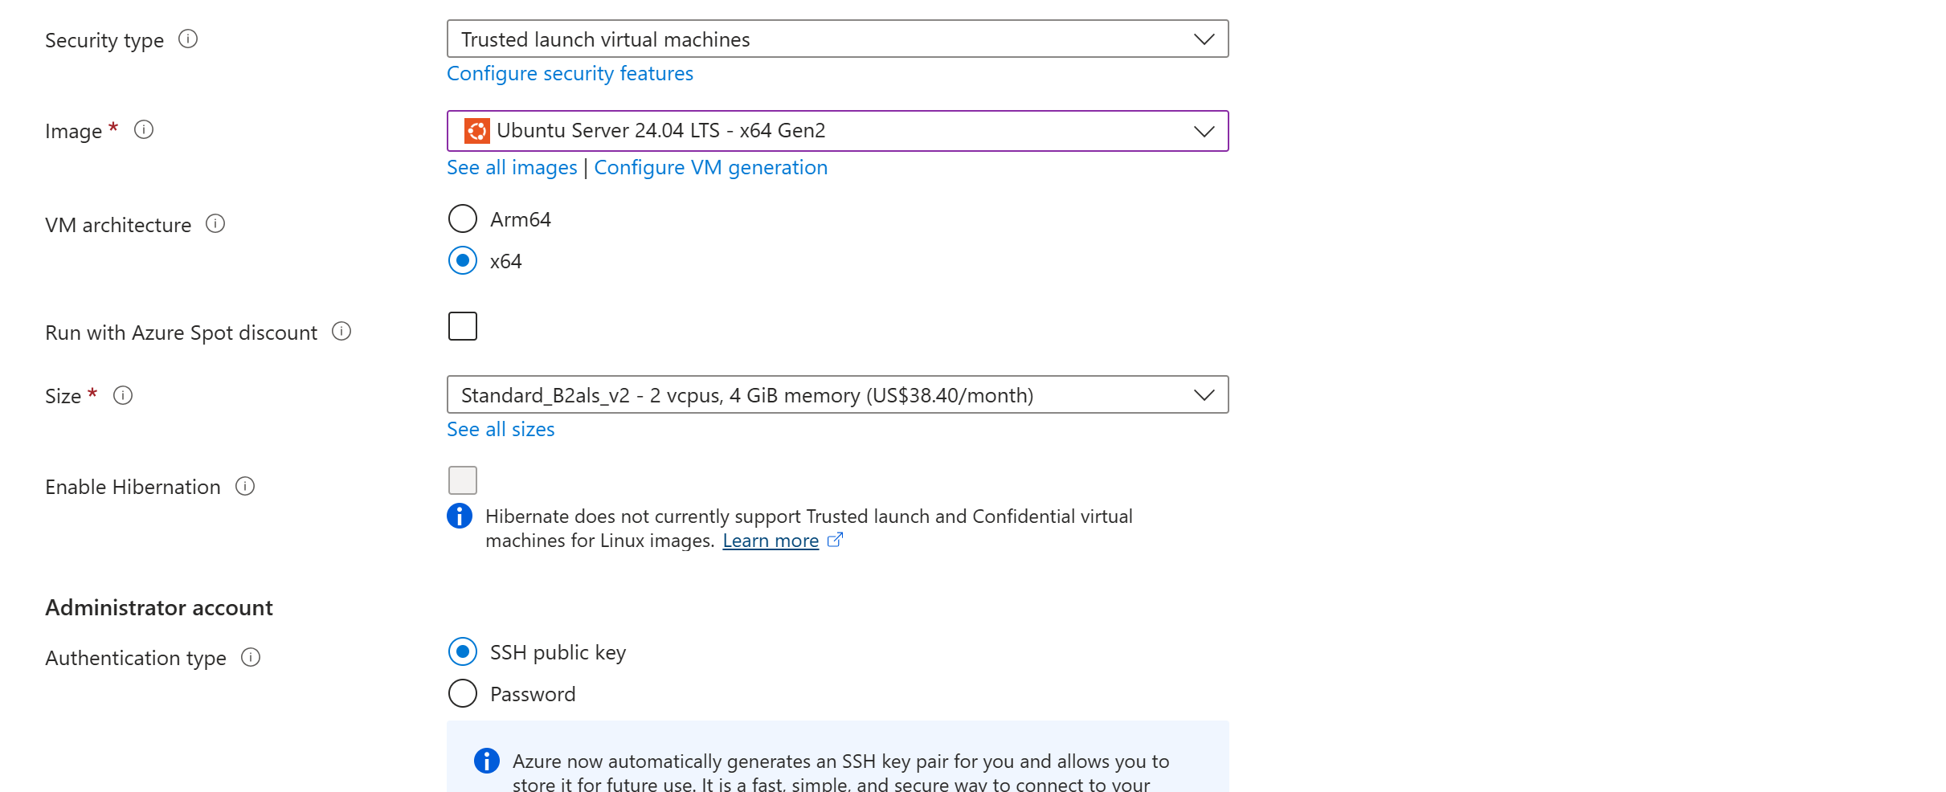

- Enable Port 80 and 22:

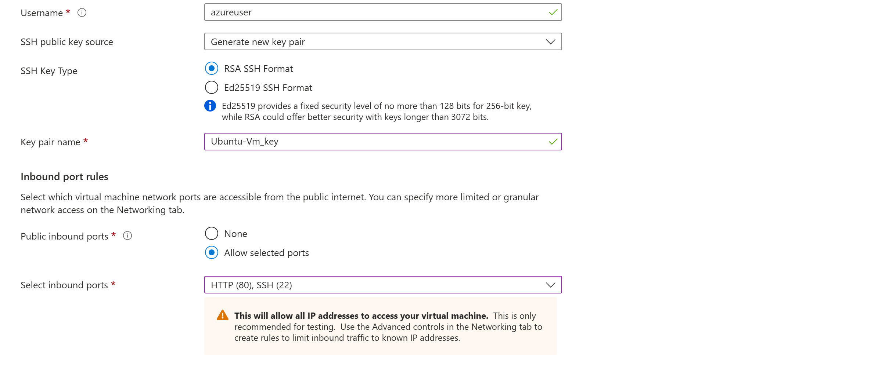

- Get SSH command:

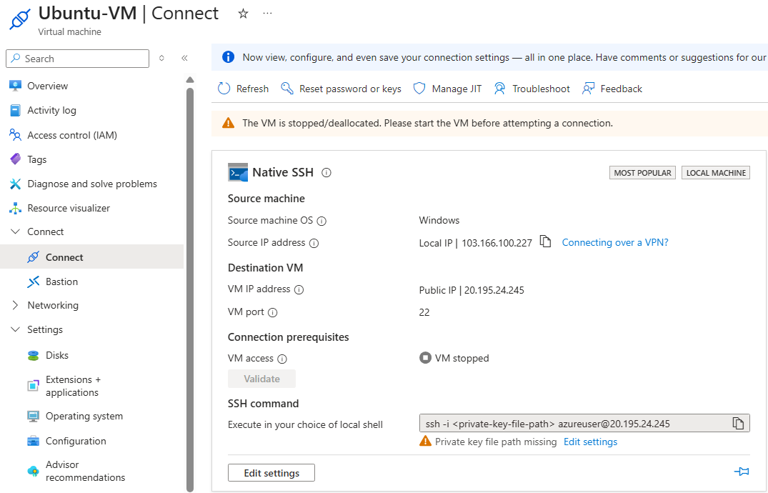
- Open Gitbash

- Run SSH command:

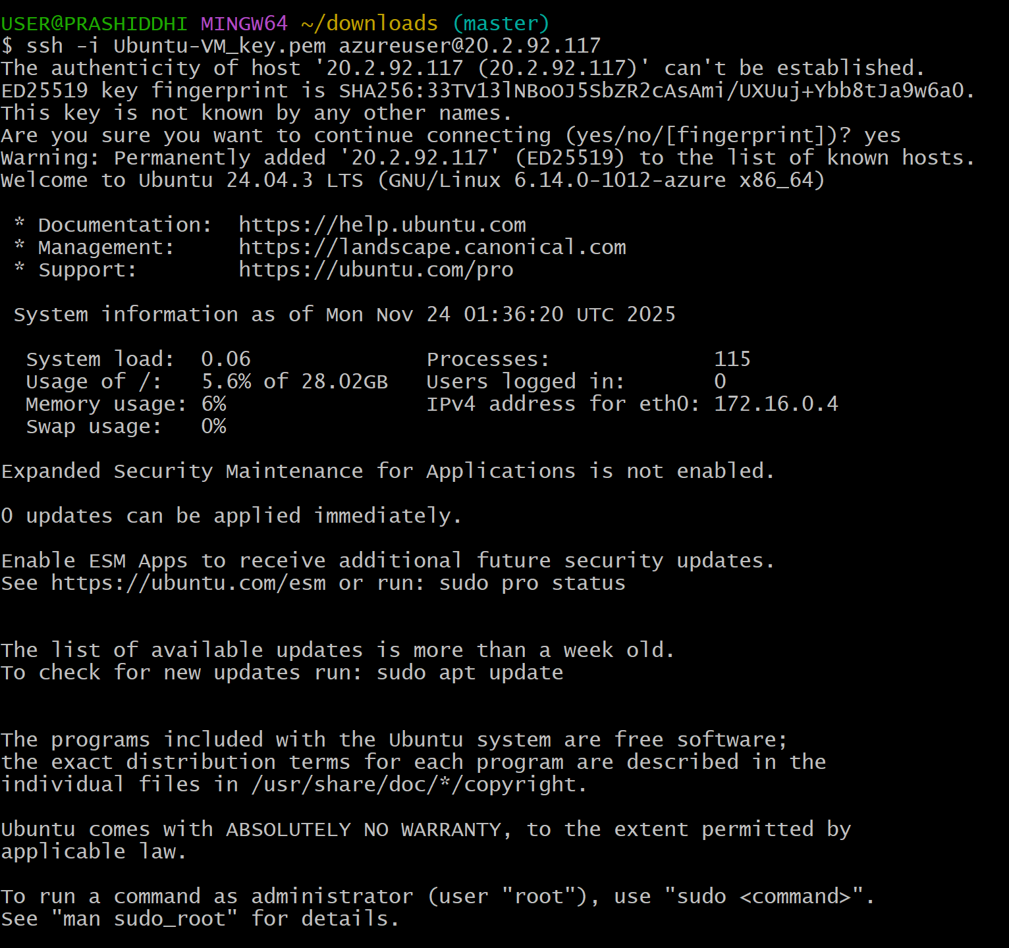

- Update to latest services using sudo apt update:
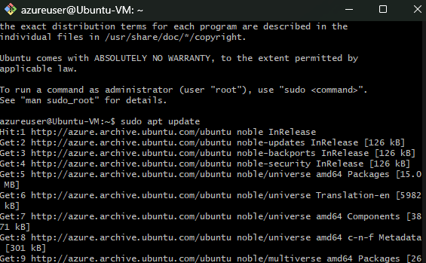

- Some basic commands:
- ip a:

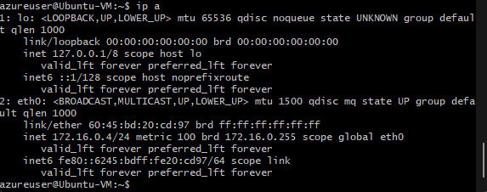

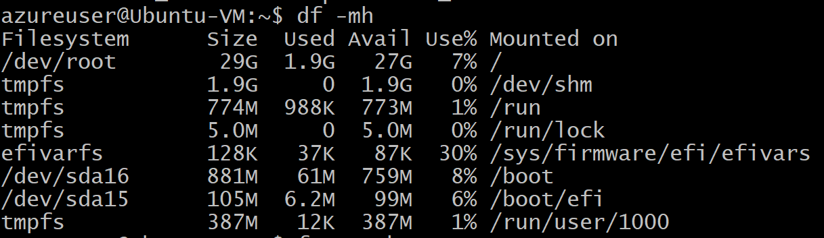
- df -mh:

- free-mh:

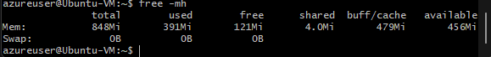

- Install Apache2:
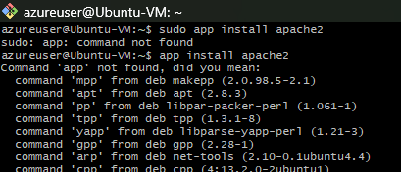

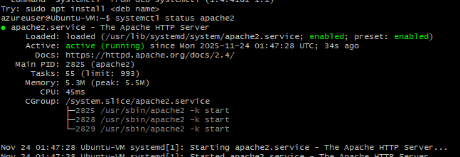

- Start Apache2:

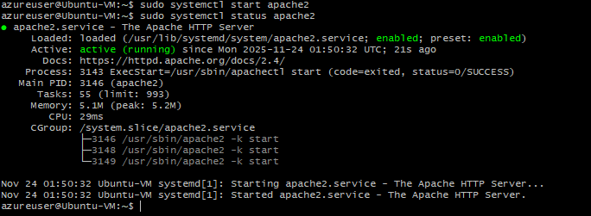

- Locate to index.html for hosting:

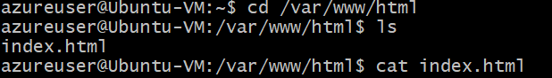

Under VM locate the Primary NIC Public IP:

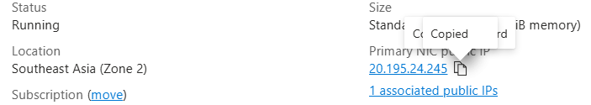

- Finally, the public IP shows the index.html:

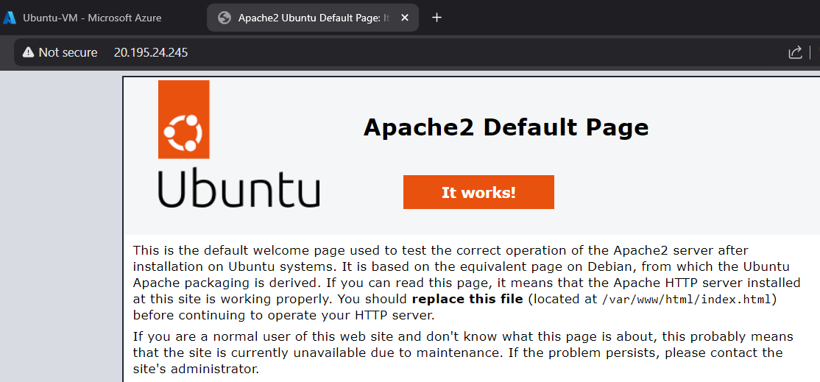

Result and Conclusion:

Result: The Ubuntu VM was successfully deployed on Azure with SSH access enabled. Ubuntu OS ran smoothly after installation and updates. Apache2 was installed without errors, and the service started automatically. A sample static website (index.html) placed in /var/www/html/ was accessible via the VM’s public IP, confirming that the web server was correctly configured and serving content.

Conclusion: Deploying Ubuntu on an Azure VM and installing Apache2 provides a simple and effective way to host static websites in the cloud. The process demonstrates how cloud infrastructure can replace physical servers, offering flexibility, remote access, and scalability. This setup is ideal for testing, development, and hosting small-scale static web applications.

